Lab S01: Setup Environment

Table of Contents

Lab S01 – Create the Azure SQL DW and objects for the Labs 3

Summary: 3

Goal: 3

Pre-requisites: 3

Resources 3

Important Notes 3

Scenario 1 – Create Objects for Labs 4

Scenario 2 – Create a Storage Account / Data Lake Gen 2 10

Scenario 3 – Create a Logical SQL Server and Sample Database 21

Scenario 4 – Create an Azure SQL Data Warehouse 33

# Lab S01 – Create the Azure SQL DW and objects for the Labs

## Summary:

This lab will walk you through the creation of the objects required for the “SQL Data Warehouse in a Day” workshops.

## Goal:

* Setup Resource group, SQL Server, SQL DW Server, Storage Account

## Pre-requisites:

* Demo files for this Lab located at <https://github.com/steveyoungca/SQLDWinaDayWorkshop> downloaded to a local folder
* Azure Subscription or Azure Subscription Pass
* Web browser (Edge/Chrome recommended)

## Resources

There are several resources that can augment your learning experience after the session. Some of these links cover material in these labs and presentations while others will help take your knowledge further. There is a link in the

## Important Notes

**Note** 1: Creating all the lab objects in the same Resource Group will make clean-up easier, as when we are complete with the labs, you delete the Resource Group and all the objects it contains will be deleted.

**Note** 2: Always pause the Azure SQL Datawarehouse when not in use to avoid charges.

1. Sign into your Azure Pass Subscription
2. Open your internet browser in safety mode (InPrivate) and navigate to portal.azure.com and enter the login credentials.

Click on the link below to create your Azure lab environment with all the necessary services. Please note that the environment is limited to $100 or $50 credit the time you sign up for it. You will be presented with the login credentials to Azure portal and other relevant details. *Record these details in a safe location*.

AzurePass Instructions - https://www.microsoftazurepass.com/Home/HowTo

Azure Pass - <https://www.microsoftazurepass.com/>

Activation Code : <<To Be Provided by proctor>>

## Scenario 1 – Create Objects for Labs

This hands-on demo will detail the steps required to create the objects required for the labs. Not all steps will have a screen shot.

| **Part 1 – Create Resource Group** | | | |
| --- | --- | --- | --- |
| **#** | **Commentary / Notes** | **Click Steps** | **Screenshots** |
|  | These initial steps will be the same for each section. Once you have created one resource, the general process will be the same. | * Open a web browser and navigate to your Azure Portal  <https://portal.azure.com> * You will be asked to sign on and authenticate |  |
|  | Create a Resource Group | * This setup is straight forward, once you are signed in, click on **Create a Resource**. |  |
|  |  | * When you select **Create a Resource**, a search bar is displayed. Type in “Resource” into the bar which will filter the list. * Select **Resource Group**. |  |
|  |  | * The Resource dialogue is starting. Select **Create** to begin. |  |
|  |  | * On the creation screen there are several items to select.  1. Select the subscription you wish to create the resource group. This is important if you have multiple subscriptions. Some people have development, MSDN, Production, Azure Pass or other purposed subscriptions. Make sure your charges are going to the correct place and billing rate. 2. Select a name for the resource group. I usually put “rg” at the beginning of the name to denote that the object in a listing is a resource group 3. Select the location. This is not as important as you can create objects in various locations / data centers. I usually select the location where the objects contained in the resource group will be created. 4. You can go directly to Review + Create, or to a Tag screen. For this example, we will show the tags. **Select Next: Tags** to continue. |  |
|  |  | * Tags can be used for organization and billing. * There are drop down values that an admin can setup or you can type in tags directly into the fields. * Select **Review + Create** to continue   “You apply tags to your Azure resources giving metadata to logically organize them into a taxonomy. Each tag consists of a name and a value pair. For example, you can apply the name "Environment" and the value "Production" to all the resources in production.”  Source: Microsoft Docs  More information on tags: <https://docs.microsoft.com/en-us/azure/azure-resource-manager/resource-group-using-tags> |  |
|  |  | * Select Create to begin the process. |  |
|  |  | * Once complete, you will see a Toast message / notification that the creation is complete. * The 2 options will allow you to Pin the resource to the dashboard, or go directly to the resource. * Select Pin to Dashboard |  |
|  |  | * With the Resource Group pinned to the Dashboard, you can see any resources that are contained. * We will create resources in the next few steps |  |

## Scenario 2 – Create a Storage Account / Data Lake Gen 2

This hands-on lab will show you the steps to create a storage account. We will also use the option to create this storage account as a data lake.

| **Part 2 – Create a Storage Account / Data Lake Gen 2** | | | |
| --- | --- | --- | --- |
| **#** | **Commentary / Notes** | **Click Steps** | **Screenshots** |
|  | These initial steps will be the same for each section. Once you have created one resource, the general process will be the same. | * Open a web browser and navigate to your Azure Portal  <https://portal.azure.com> * You will be asked to sign on and authenticate |  |
|  | These initial steps will be the same for each section. Once you have created one resource, the general process will be the same. | * Open a web browser and navigate to your Azure Portal  <https://portal.azure.com> * You will be asked to sign on and authenticate |  |
|  | Create a Storage Account | * This setup is straight forward, once you are signed in, click on **Create a Resource**. You can also use the icon **Storage Accounts** which will display all the storage accounts you currently have in the selected subscription. |  |
|  |  | * When you select **Create a Resource**, a search bar is displayed. Type in “Storage Account” into the bar which will filter the list. * Select **Storage Account**. |  |
|  |  | * The Storage Account creation screen will display. * Note the **Useful Links** at the bottom, these are available for most of the objects you are creating in Azure. These will provide links to documentation. * Select **Create** to begin the process. |  |
|  |  | * The first screen allows you to put in the basic information  1. These are the Basic options 2. Select the **subscription** you with to create this under. 3. Select the **Resource Group** created in the previous step. This should be listed in the drop down. 4. Give the **Storage Account** a name. Try to provide something easy to remember. 5. Select the **Region**. This is important as it should be in the same region that your data will reside and be used in. If you have objects in different regions, such as the storage and applications/services that use this data, you will have data charges on that data transmitted between the data centers / regions. See link below. Inbound is free, outbound data transfers have a fee. <https://azure.microsoft.com/en-us/pricing/details/bandwidth/> 6. Select **Standard** or Premium Storage. Premium storage is usually for VMs and those types of workloads. <https://azure.microsoft.com/en-us/blog/introducing-premium-storage-high-performance-storage-for-azure-virtual-machine-workloads/> 7. Select Storage V2 as the Account Kind 8. For this lab, you only need Locally Redundant. <https://docs.microsoft.com/en-us/azure/storage/common/storage-redundancy> 9. This storage will be HOT storage. Cold is for archive. <https://docs.microsoft.com/en-us/azure/storage/blobs/storage-blob-storage-tiers> 10. Select **Next**: Advanced to move to the next set of options. | This link provides general information on Azure Storage Accounts. <https://docs.microsoft.com/en-us/azure/storage/common/storage-introduction> |
|  | Note that the Data Lake Storage Gen2 will be disables for this lab. | * This screen allows you to select various advanced options.  1. Set the **Secure Transfer Required** to **Enabled**. <https://docs.microsoft.com/en-us/azure/storage/common/storage-require-secure-transfer> 2. For this set of labs, select **All Networks**. 3. **Disable** Data Protection for soft delete. <https://azure.microsoft.com/en-us/blog/soft-delete-for-azure-storage-blobs-ga/> 4. For this set of labs we will **Enable** this option. <https://docs.microsoft.com/en-us/azure/storage/blobs/data-lake-storage-quickstart-create-account>   Select Next: Tags to create Tags. |  |
|  |  | * Tags can be used for organization and billing. * There are drop down values that an admin can setup or you can type in tags directly into the fields. * Select **Review + Create** to continue   “You apply tags to your Azure resources giving metadata to logically organize them into a taxonomy. Each tag consists of a name and a value pair. For example, you can apply the name "Environment" and the value "Production" to all the resources in production.”  Source: Microsoft Docs   * More information on tags: <https://docs.microsoft.com/en-us/azure/azure-resource-manager/resource-group-using-tags> |  |
|  |  | * Select Create once you reviewed the options. |  |
|  |  | * You can follow the deployment process |  |
|  |  | * The Toast / alert message will allow you to pin this resource to your dashboard. * The Deployment process, when complete, will have a button to take you to that resource. |  |
|  |  | * Once, compete you can go to the Resource. * We will walk though some of these options during the LAB time. |  |
|  |  | * Once created and pinned, your Dashboard may look something like the capture on the right. |  |

## Scenario 3 – Create a Logical SQL Server and Sample Database

This hands-on lab will show you the steps to create a storage account. We will also use the option to create this storage account as a data lake.

| **Part 3 – Create a Logical SQL Server and Sample Database** | | | |
| --- | --- | --- | --- |
| **#** | **Commentary / Notes** | **Click Steps** | **Screenshots** |
|  | These initial steps will be the same for each section. Once you have created one server, the general process will be the same. | * Open a web browser and navigate to your Azure Portal  <https://portal.azure.com> * You will be asked to sign on and authenticate |  |
|  | Create a SQL Server | * This setup is straight forward, once you are signed in, click on **Create a Resource**. * Select SQL Server * This will create a SQL Logical Server. Azure SQL Database and Azure SQL Data Warehouse will belong to the same logical server and show up together. * During this process there is an option to create the Sample Adventure Works database which we will do. |  |
|  |  |  |  |
|  |  | * There is also a listing of popular resources on the same screen, SQL Database is highlighted with the arrow. This can be selected also as a shortcut, or you can select the Quick Start tutorial. For this example, we will select from the drop down list. * Type in **SQL Database** into the search box. * Select SQL Database from the drop-down list. |  |
|  |  | * Select **Create** to start the process |  |
|  |  | * The blades will walk you through various basic and Advanced settings. * You can create just a SQL Logical Server using PowerShell, but we will use the Portal to create an Azure SQL Database  1. Select the **Subscription** to create this Server and Database to 2. Select the **Resource Group** that you want to have this SQL Server associated with. 3. This will create a SQL Relational Database, Provide a **Name**. You can use caps in this name 4. IF we do not have a server to select, we can create a New on by selecting the **Create New** option. A new blade will appear to enter the information for the server.  These steps are in the row below. |  |
|  | For the Location of the server, step 5, your subscription may not allow you to create the server in certain regions. You will get a red message. East US 2 is an open region for most subscriptions.  Some subscriptions are trials, development etc.  Make a note of the Admin login and password as you will need this for the SQL Server Management Studio login in a future lab. | * To create the **New Logical Server**, fill in the following information.  1. Enter a name for the server. You are limited to lowercase characters. 2. Enter a SQL Login for administrator. There is an option once setup to add in an Azure Active Directory Admin account. (LabAdministrator) for example. 3. Enter in a strong password 4. Validate the password 5. Select the Location. East US 2 is our selected data center. 6. Select the Allow Azure Services to access Server <https://docs.microsoft.com/en-us/azure/mysql/howto-connect-webapp> 7. Hit the Select button at the buttom of the blade. |  |
|  |  | * Continuing from step 7,  1. We do not want to enable elastic Pools for this database. Select **No**. 2. We will configure the database in the row below. Select **Configure Database**. |  |
|  |  | * Without going into a lot of detail, there are many option for creating a database. * More information on these new levels and Tiers are available here, <https://docs.microsoft.com/en-us/azure/sql-database/sql-database-single-database-get-started> * Remember this is for the SQL Database we are creating not the Server. * For the Labs, and keeping costs down, we are going to select the Left **Arrow for the Basic, Standard or Premium option.** |  |
|  |  | * Select the Standard and keep the options. S * Select Different options and see how the pricing changes, but go back to the options pictured on the right to keep the costs low for the Labs. * Select **Apply** to return to the Create SQL Database Screen. |  |
|  |  | * Select the Next: Additional Settings screen. |  |
|  |  | * Let’s choose the following options  1. The default starting database option is set to None. We can create a database from a backup or use the Sample Database. Select **Sample**. 2. We will leave the other options as the default. Note what you can change. 3. Select **Next:Tags** to go to the next screen.   The Sample should look like this. |  |
|  |  | * Tags can be used for organization and billing. * There are drop down values that an admin can setup or you can type in tags directly into the fields. * Select **Review + Create** to continue   “You apply tags to your Azure resources giving metadata to logically organize them into a taxonomy. Each tag consists of a name and a value pair. For example, you can apply the name "Environment" and the value "Production" to all the resources in production.”  Source: Microsoft Docs   * More information on tags: <https://docs.microsoft.com/en-us/azure/azure-resource-manager/resource-group-using-tags> * Select **Review and Create** to validate your settings. |  |
|  |  | * Your setup should look like the following. |  |
|  |  | * Your screen as you deploy the SQL Server. * Once Complete, a **Go To Resource** button will be displayed, select this when displayed. |  |
|  |  | * When you go to the resource, the SQL Server you created, you will see the database you selected. Because in step 12, we selected sample, the database will have the AdventureWorksLT installed. * I usually have a sample database installed so I can do some testing and setup. |  |

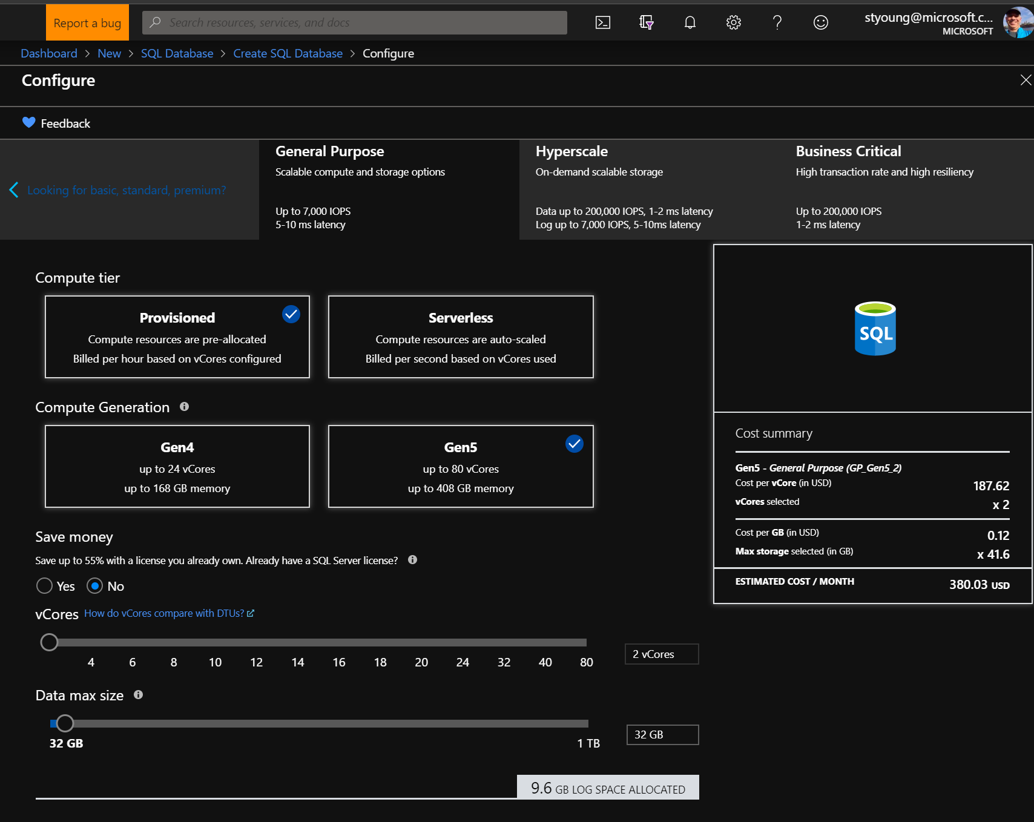

## Scenario 4 – Create an Azure SQL Data Warehouse

This hands-on lab will show you the steps to create a storage account. We will also use the option to create this storage account as a data lake.

| **Part 4 – Create an Azure SQL Data Warehouse** | | | |
| --- | --- | --- | --- |
| **#** | **Commentary / Notes** | **Click Steps** | **Screenshots** |
|  | These initial steps will be the same for each section. Once you have created one server, the general process will be the same. | * Open a web browser and navigate to your Azure Portal  <https://portal.azure.com> * You will be asked to sign on and authenticate |  |
|  | Create a Azure SQL Data Warehouse Server | * This will use the SQL Logical Server created in the previous step. Azure SQL Database and Azure SQL Data Warehouse will belong to the same logical server and show up together. * This setup is straight forward, once you are signed in, click on **Create a Resource**. |  |
|  |  | * For this example, we will select from the drop down list. Type in **SQL Data Warehouse** into the search box. * Select SQL SWL Database from the drop-down list. |  |
|  |  | * Select **Create** to start the process |  |
|  |  | * This screen is very similar to the Azure SQL Database screens.  1. Select the **Subscription** you wish to use 2. Select the **Resource Group** we created in the previous section. 3. Enter a **Data Warehouse Name**. Use **AdventureWorksDW** for the scripting labs**.**      1. Select the Server that we created in the previous step from the Drop down. 2. Select the **Select Performance Level** link |  |
|  |  | * The **Select Performance Level** will display**.** * Select **Gen2** * Moving the **Scale Your System** slider will change the cost and performance. Select DW200 for the lab. * Select the Apply at the bottom of the screen |  |
|  |  | * Review your entries, and then select the  **Next: Additional Settings** |  |
|  |  | * These additional settings will allow you to restore a backup, or add a **Sample** option. Selecting Sample, as we need for our labs, will be the Adventure Works DW. * Select **Next: Tags** to continue. |  |
|  |  | * Tags can be used for organization and billing. * There are drop down values that an admin can setup or you can type in tags directly into the fields. * Select **Review + Create** to continue   “You apply tags to your Azure resources giving metadata to logically organize them into a taxonomy. Each tag consists of a name and a value pair. For example, you can apply the name "Environment" and the value "Production" to all the resources in production.”  Source: Microsoft Docs   * More information on tags: <https://docs.microsoft.com/en-us/azure/azure-resource-manager/resource-group-using-tags> |  |
|  |  | * Review the create screen and select **Create**. |  |
|  |  | * Once the deployment is underway, this screen will update. |  |
|  |  | * Updates along the way * Click on **Go To Resource** when complete |  |
|  |  | * The resource will be deployed and displayed. * Always, Always remember to **Pause** if you do not need this database running. This will avoid the operational charges. You may still have storage charges depending on options. |  |
|  |  | * Selecting **Pause** will check if there are any active connections and provide you a **YES** to pause. |  |
|  |  | * Your dashboard Resource tile should look like this when complete. |  |
|  |  | * Your Database Server should have both databases displayed. |  |
|  |  | * This should be how your resource group appears after your Lab 01 is complete. |  |